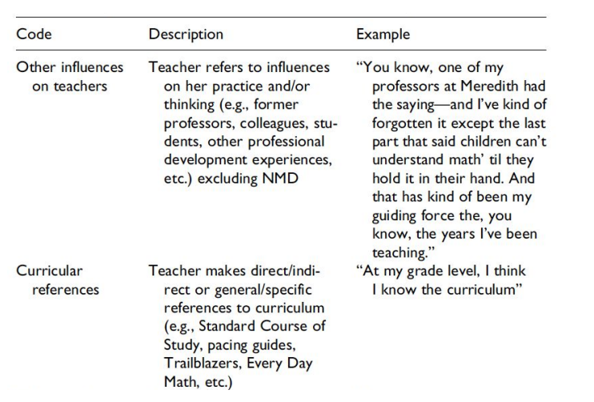

| Code | Description | Example |
| --- | --- | --- |
| Financial education | A lot of the young adults seem to say that they could spend less because they don’t evaluate or track everything. They also say that they don’t really want to track or plan their expenses. They seem to be willing to learn more about saving but that it shouldn’t be a constraint. They want to be educated in the financial field but it must be an interesting way. It should be advice that could lead to real actions. | “I think that financial literacy should be done as a gamification in order to make things more accessible, like giving objectives, having data to see our evolution….”  “It would be interesting to have financial literacy but can be annoying to have to read long stuff”  “I would prefer an app that helps me saves money, for example, rounds the money spent to the above number and put it in another account [than an app that only helps me analyze my depenses]” |
| Savings management | For most of the interviewed young adults, their salary is divided in 3 (not always evenly) : fixed costs (rent, phone bill, transportation, groceries, ...) , other expenses (hobbies, going out with friends, clothing, …), and savings.  Many of them would also like to do more but are limited by their income.  Perhaps a way to help them would be to implement a way to plan their savings or to manage their money depending on the category they allow themselves to spend more or less in. Thereby, they could manage their money better and maybe do some of the things/achieve goals they thought were limited by their income. | “I use 50% of it for monthly expenses and the rest is for savings.”  “I have to set aside an amount for dates and gifts.”  [If I had more money, I’d spend it in ] “Better apartment and maybe better restaurants, more savings” |
| Investment Planning | Many of the young adults that we interviewed say they plan to invest in real estate, in their business, or in an apartment for themselves. This “planning” is very generic and doesn’t have specific dates or an actual plan to be put into motion. This planning gap is an area that could be further investigated and implemented in some kind of financial app to help these young people. | "Would like to buy real estate."  "Move to another country or open my tourism business."  "Invest in real estate (in France), he wants create his business but for the moment not calculated in his costs, repay his loan in 2-3 years (he is already starting to repay)." |